1. Log in AWS IoT, And create a goods.
2. You should create a type before, and fill in the name of the goods, and then click the Next.

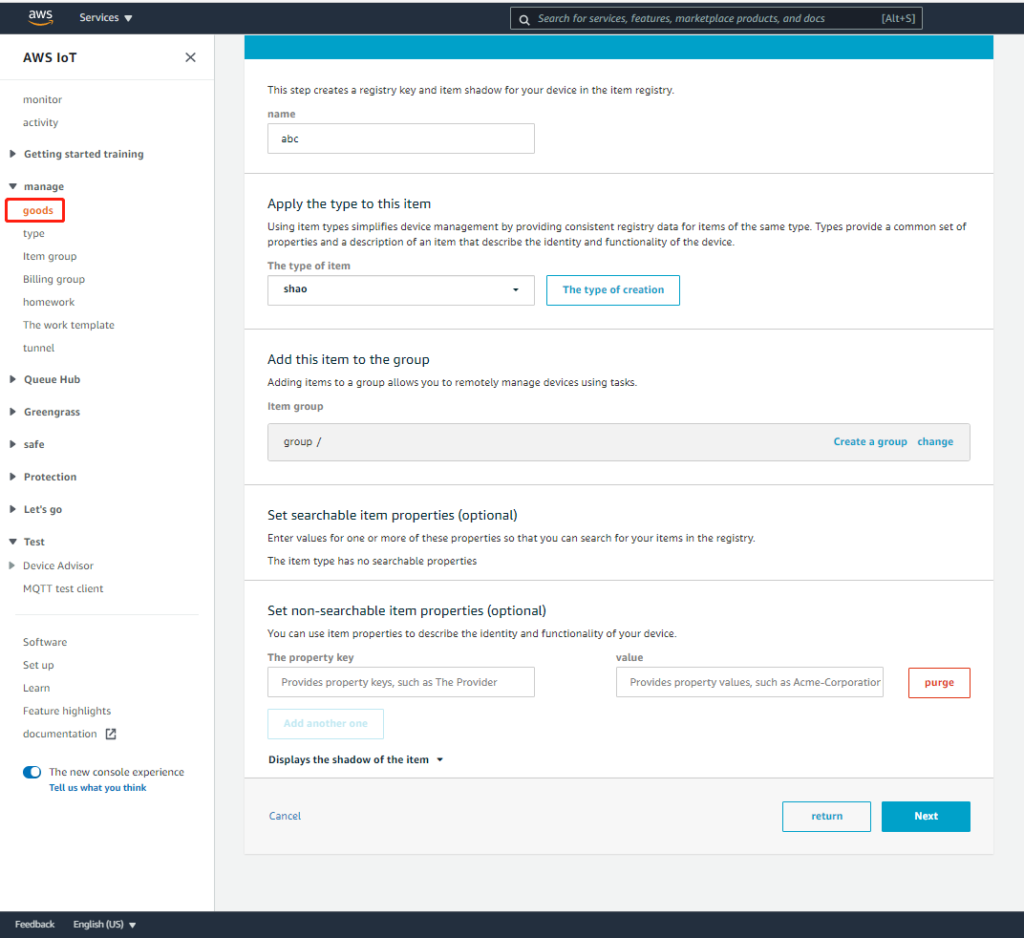

1. Click Create a certificate to generate the certificate and key.

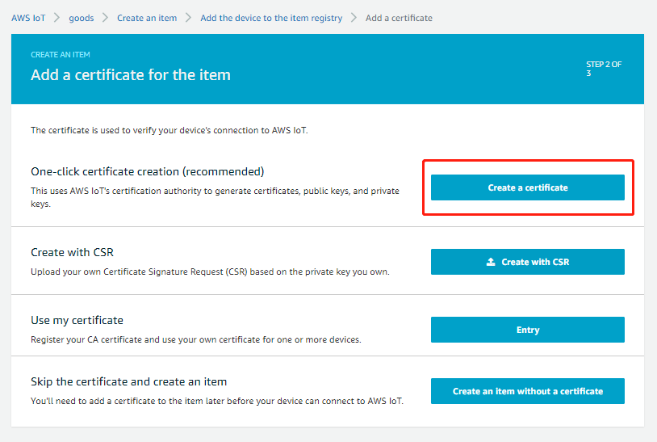

1. Download The certificate for the item, Private key and The root CA of AWS IoT to local, then click activation. Attention: you should add the additional policies.

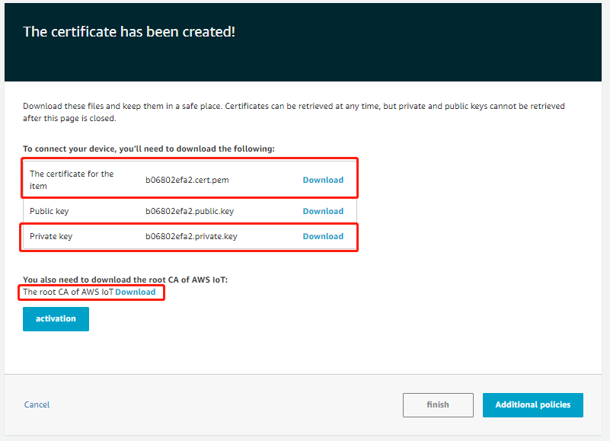

1. Open the project of PLCnext Engineer, Like IIOT_TEST_AWS_PUB_2.pcwex.open the programs variables list, you can see ca_path, cert_path and key_path. Please put these three files you downloaded before to /opt/plcnext/certs/ in PLCnext. And fill in the correct initial value in variables list, like STRING#'/opt/plcnext/certs/5623f3a342-certificate.pem.crt'.

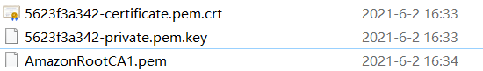



1. Connect to PLCnext and go into debug mode.
2. Find the IIOT_AwsCertificataInfo_1 function block, set config_en as TRUE. If o_valid output TRUE, it means the certificate, key and ca is valid.

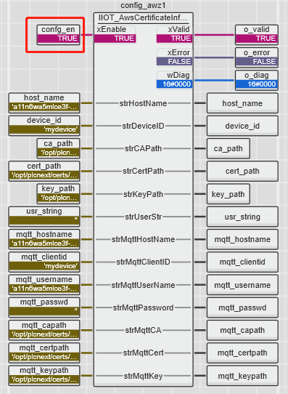

1. Then find the MOTT_Client_1.Connect function block, set Run as TRUE. If Step output Running 2, it means connect succeed.

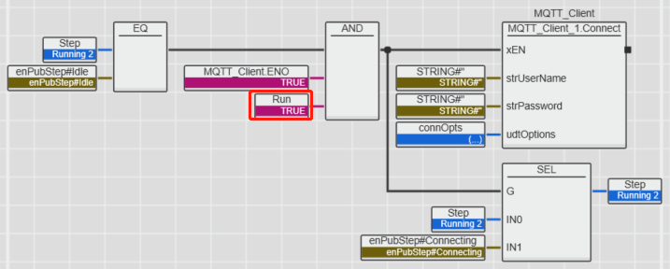

1. Open the MQTT test client in AWS IoT. Copy the TOPIC value of project to AWS IoT. Subscribe the topic and you can receive the message from PLCnext.



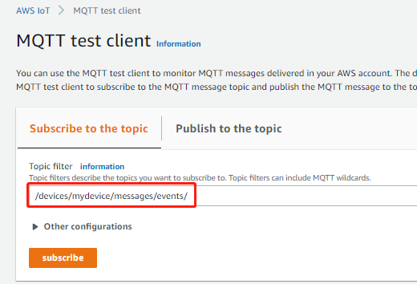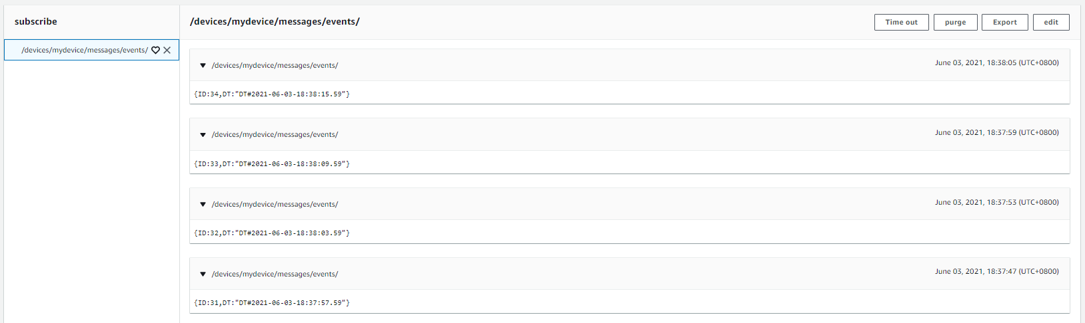

If you want to realize subscribe function in PLCnext, you can open IIOT_TEST_AWS_SUB_2.pcwex project. Steps are the same. And you can see the message topic, meaasge contents and message information from msgTopic, msg, msgInfo these three variables.

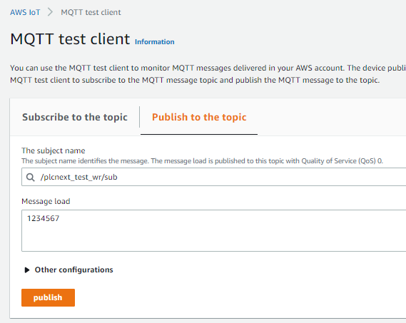

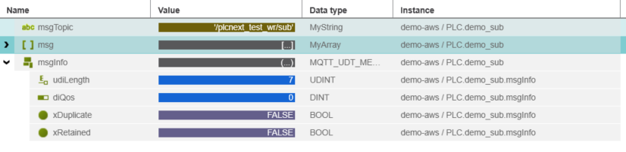

Attention: Make sure your PC time is correct, or the certificate you download is invalid.